System Analysis and Design I

Online DVD Rental System

**Background:**

An online DVD rental system offers customers the possibility to search and rent their favorite films from the comfort of their homes or workplace, without the hassle of queuing or having to go to the physical shop high street.   
  
Customers of the DVD rental system can login to the website once they have been registered and browse through the various categories to find the favorite titles. It is possible to rent up to three DVDs at the time. Different subscription packages are available starting from £10 a month.

Once the customer has selected and clicked on “Rent”, the DVD gets shipped to the customer’s registered address without any extra cost. Customers can keep DVDs as long as they like but once a DVD is returned a new DVD from the “wish list” will be shipped to the customer’s address until they decide to pause or stop the service. The policies relating to return, loss and damage will be available on the website.

**Functional Requirements:**

* The system must prompt new customers to register before renting a film
* The system must allow customers to store card details for subscription.N
* The system must allow customers and support assistant to cancel their membership type anytime.
* The system must allow the customer to rent DVD’s.
* The system must allow to track orders and returned films.

**Actors:**

* Customer
* Support Assistant
* Warehouse / Distribution Manager

**Use Cases:**

* The Customer can access to the DVD Rental website to browser for their favorite film titles, In order to rent any DVD they must register first with their personal and payment details. They can create and cancel their account anytime by contacting the support assistant. Once registered the customer can browse for firms and order them. It is the Customer responsibility to return the DVDs to the company.
* The Support Assistant is responsible for tracking the orders generated by the system, it also their responsibility to deal with any Customer enquiries such as: damage or lost DVDs, payments and edit orders, they can also provide support to cancel the subscription or validate payments.
* The Warehouse / Distribution Manager is the person who receives the orders from the Support Assistant to submit the DVD parcel to the Customer registered address, once the transaction has been processed. The Warehouse / Distribution Manager is also responsible to generate reports of the number of DVDs dispatched monthly.

**Use Cases Diagram:**

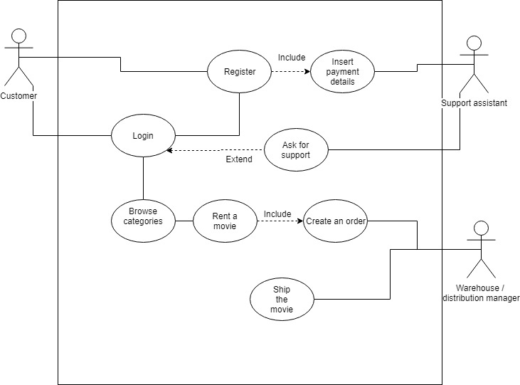

**Use Cases Description:**

|  |  |
| --- | --- |
| Use Case | **Register** |
| Brief Description | This use case allows the customer to register their personal details, including their delivery address and payment details |
| Actors | Customer |
| Preconditions | The customer must be a new customer, browse the online DVD rental website, find and click in the register button to display the register form. |
| Main Flow | 1. The new customer clicks in the “register button” located in the main menu of the website. 2. The website will display the register form. 3. The website collects the new user’s data through the form 4. The website will then validate the customer’s details 5. Then new customer details will be stored in the DVD rental Database 6. The new customer will receive an email confirming that their details have been registered in the database. |
| Alternative Flows | (7) Redisplay the form if the customer clicks on register without filling the mandatory fields |
| Post Condition | The existing customer must access with the same login details he registered before if any of the login details have changed since registered, they must be the ones from the last entry. |

|  |  |
| --- | --- |
| Use Case | **Login** |
| Brief Description | This use case allows the customer to log in to the DVD rental website with their login details |
| Actors | Customer |
| Preconditions | The customer must be an existing customer, browse the online DVD rental website, find and click on the login button to access to his account in the DVD rental website. |
| Main Flow | 1. The use case begins when the existing customer access to the DVD rental website. 2. The existing customer enter their login details, username and password 3. Their details get validated against the customer database 4. The website system grants access to the existing customer and display their account. |
| Alternative Flows | (5) Redisplay login form if account not found in the database |
| Post Condition | The access login details granted by the support assistance, must be changed by the customer for security reasons. |

|  |  |
| --- | --- |
| Use Case | **Insert payment details** |
| Brief Description | This use case allows the customer to register their payment details and verified them. |
| Actors | Customer and Support Assistance |
| Preconditions | The Customer must provide all of the payment details required in the form. |
| Main Flow | 1. Once the customer has completed the personal details, including the delivery address, the customer will click to the next button. 2. The next screen will display a new form containing the payment details form. 3. The customer must fill all of the details required in the form. 4. Once the customer clicks the submit button, the customer details would be check with their bank database. 5. If the payment details are correct and not reported as stolen or lost by the bank, the website system will return a thank you page, prompting that they have been successfully registered. |
| Alternative Flows | (6) If the payment details are reported as stolen or lost by the bank verification system, the registration must end and the DVD rental website system must redirect the customer to a different page, prompting them to contact their back. |
| Post Condition | The customer must not try to start the registration process with the same payment details without receiving clearance from their bank. |

|  |  |
| --- | --- |
| Use Case | **Browser Categories** |
| Brief Description | This use case allows the customer to search throughout the DVD rental website and filter films by categories. |
| Actors | Customer |
| Preconditions | The customer must login with their user and password to access to the categories section |
| Main Flow | 1. Based on their film preferences which they selected when registered, a default screen will display with the latest film titles from those categories. 2. A panel with all film categories will be also available on the website as well as a search field for individual 3. Once the customer has found their favourite film, they will be able to select |
| Alternative Flows | none |
| Post Condition | none |

|  |  |
| --- | --- |
| Use Case | **Rent a Film** |
| Brief Description | This use case allows the customer to rent a film from the DVD rental website. |
| Actors | Customer |
| Preconditions | Films which the customer wishes to rent, must be selected first. |
| Main Flow | 1. Select the movie 2. Open page with information about the movie 3. The customer must agree with the terms and conditions before continuing. 4. Once the customer has agreed on the terms and conditions a thank you page will be display and a confirmation email will be sent to the customer registered e-mail address. 5. A dispatch order would be generated in the system |
| Alternative Flows | 6. If a movie is not available an error will display and the user will be prompt back to the movie page  7. If a customer tries to rent without accepting the terms an error will display prompting the user back to the movie page |
| Post Condition | none |

|  |  |
| --- | --- |
| Use Case | **Creates an Order** |
| Brief Description | This use case explained the film order process |
| Actors | Support Assistance and Warehouse and Distribution (WD) Manager |
| Preconditions | A dispatch order must be generated |
| Main Flow | 1. Once a new dispatch order is available in the system, track reference number will appear in the support assistance dashboard 2. The track reference will generate a new task on the WD manager dashboard with ‘’pending’’ status 3. The WD manager process the new task and moves the new task to “in process” status 4. The WD manager check the film details and the customer delivery details and prints them in a single label and place it on the film parcel. 5. The WD manager place the parcel in the post and updated the task to “completed” status 6. The support assistance receives a message with the updated status of the track reference. 7. The system will generate and email with a delivery estimated time and track reference and send it to the client registered email address |
| Alternative Flows | If for some reason the film is not available, an email will be sent to the customer asking to review their request. |
| Post Condition | An email must be sent to the customer. |

|  |  |
| --- | --- |
| Use Case | **Dispatch the Film** |
| Brief Description | This use case explained the film dispatch and delivery process |
| Actors | Customer, Support Assistance and Warehouse and Distribution (WD) Manager. |
| Preconditions | Only Orders that have been completed by the WD manager can come into this process |
| Main Flow | 1. Once the order has been completed by the WD manager, the system will generate and e-mail with a delivery estimated time and track reference to the customer. 2. The film parcel goes into the post process. 3. The client received the film |
| Alternative Flows | (4) If the parcel gets lost/arrives damaged the customer can ask for support |
| Post Condition | If the Alternative flow has been activated more than twice the Support assistance must review the case and contact the customer. |

**Activity Modeling:**

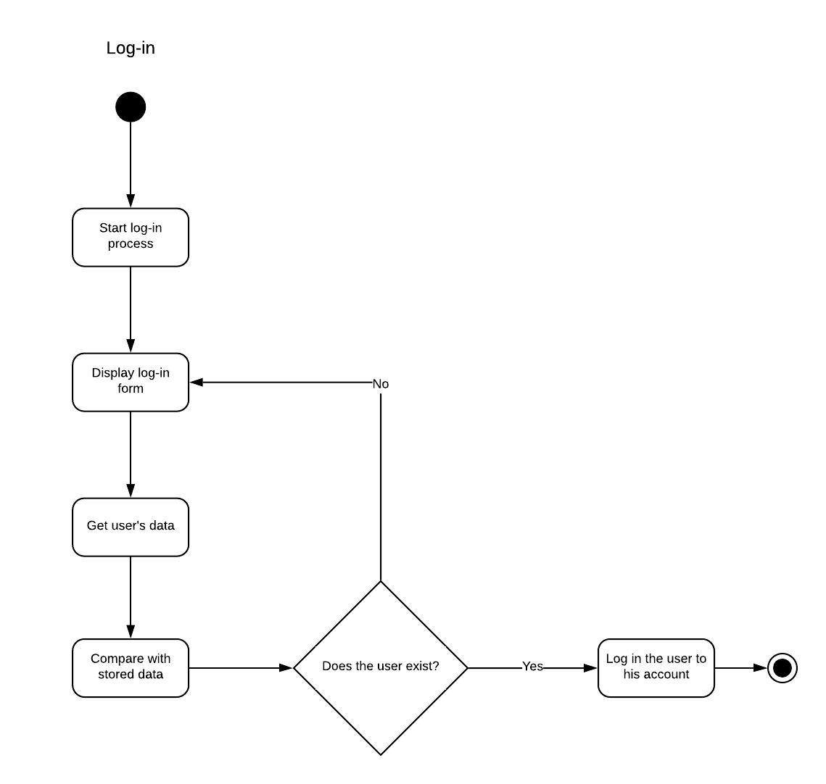

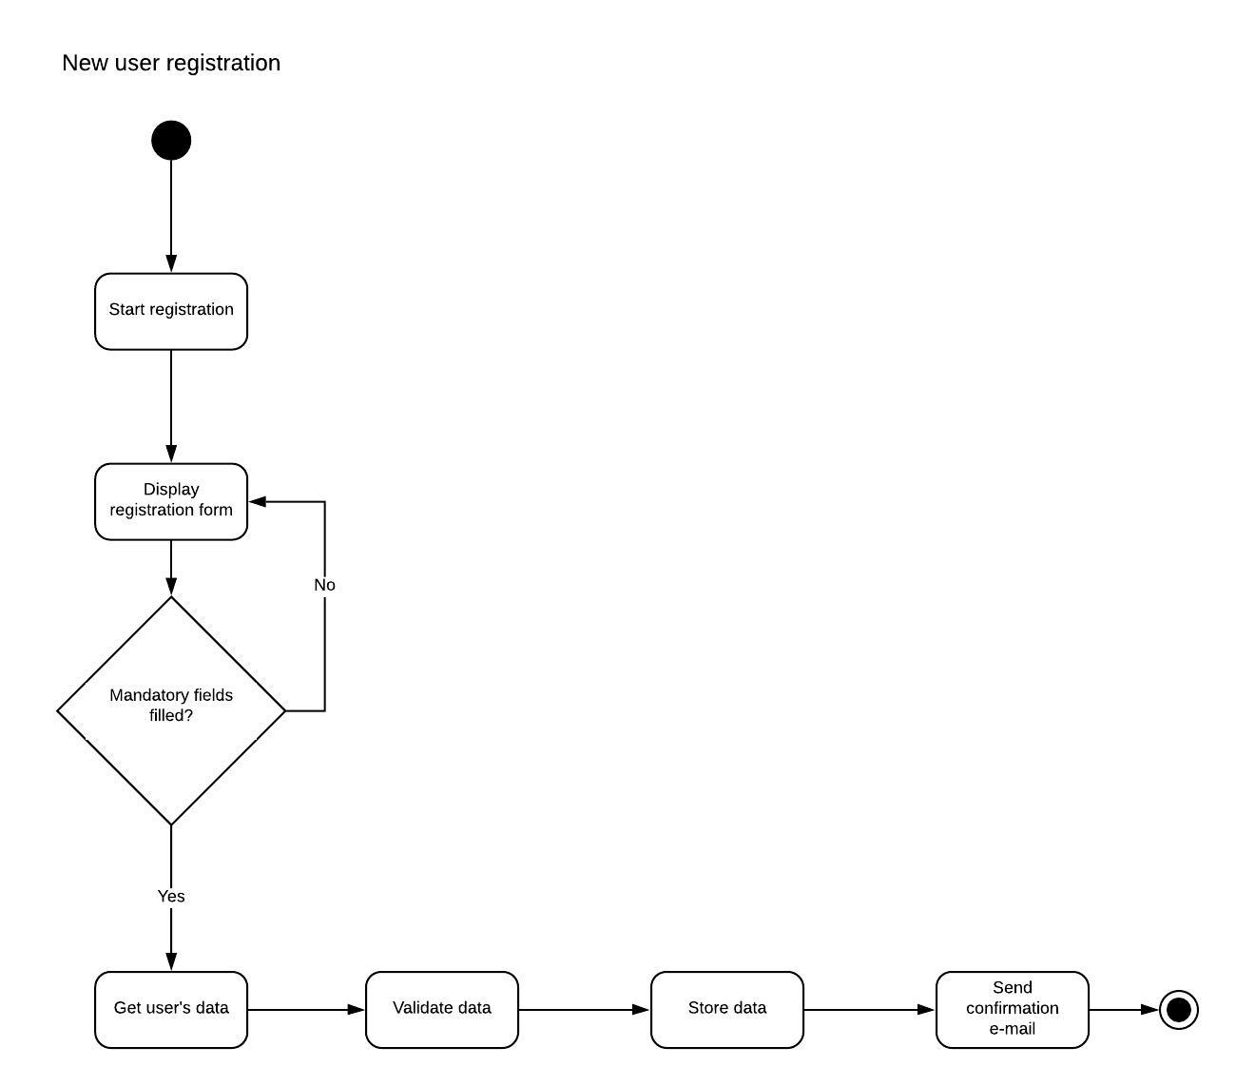

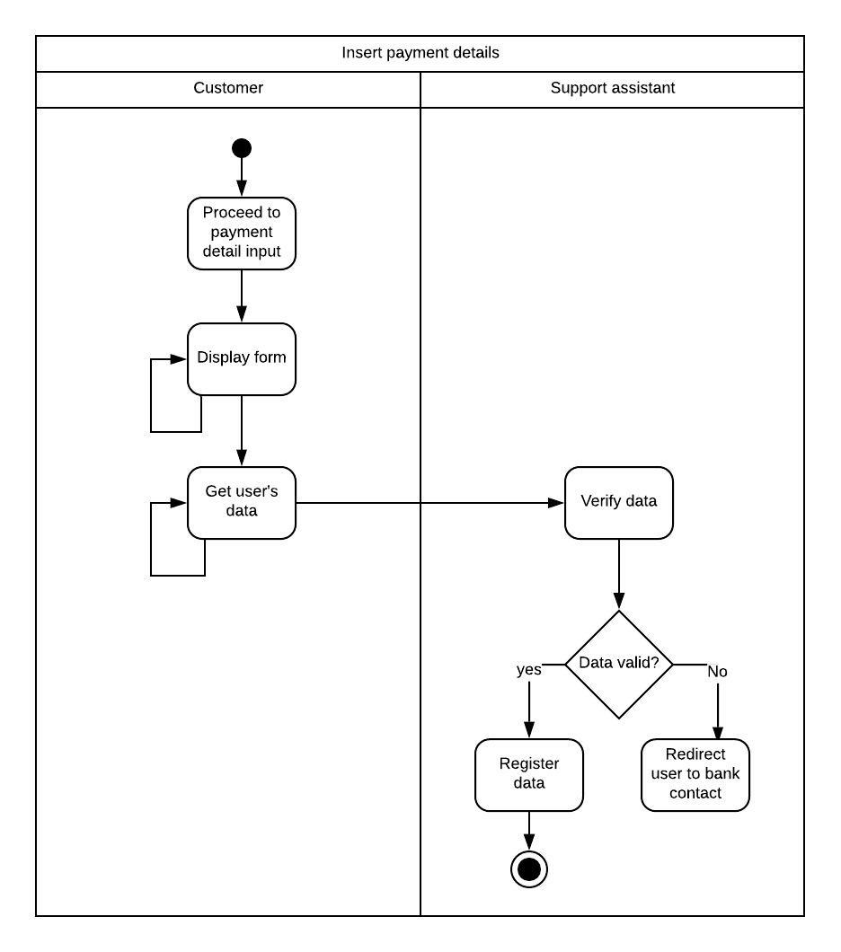

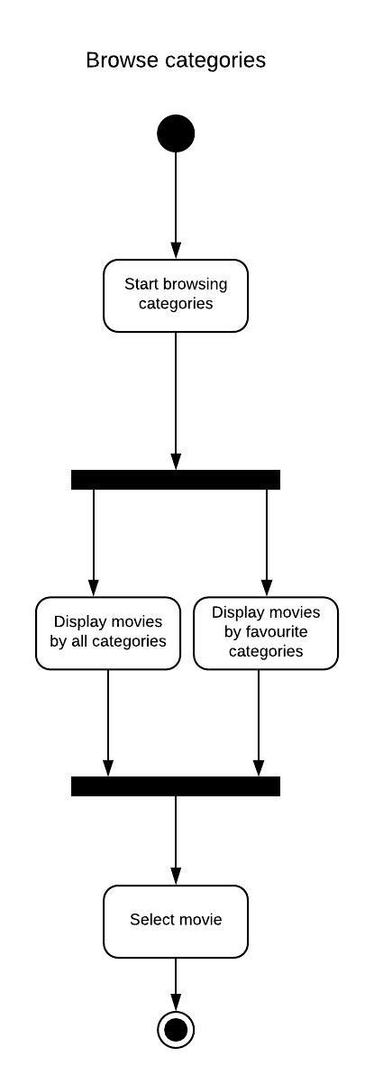

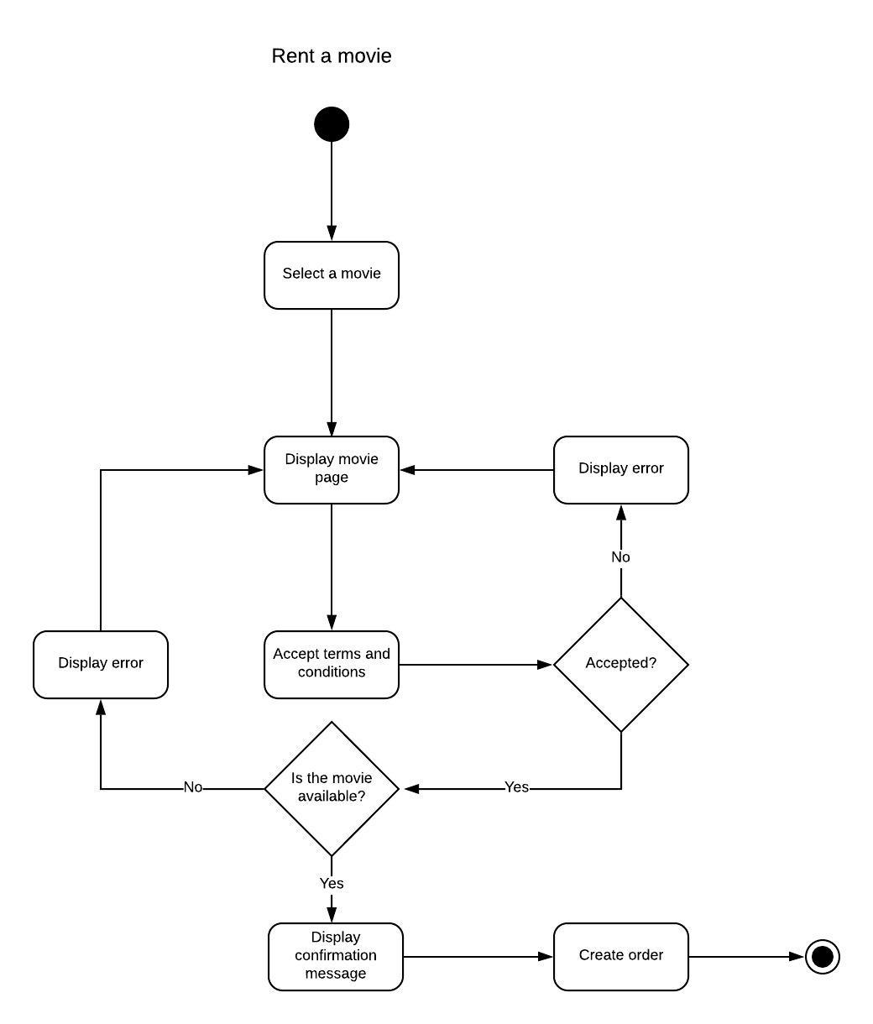

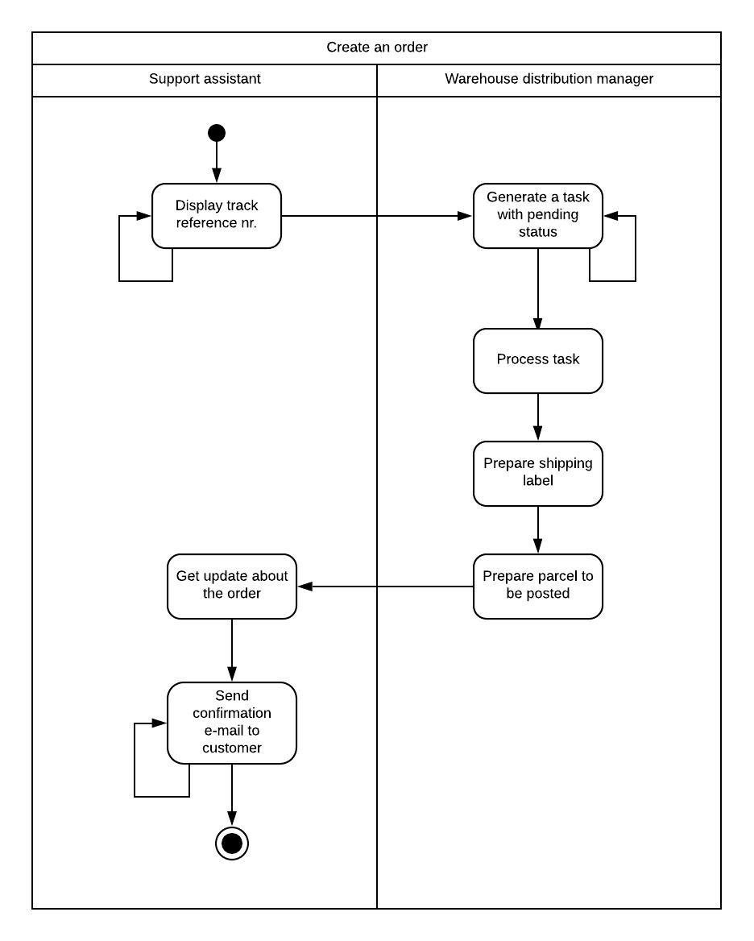

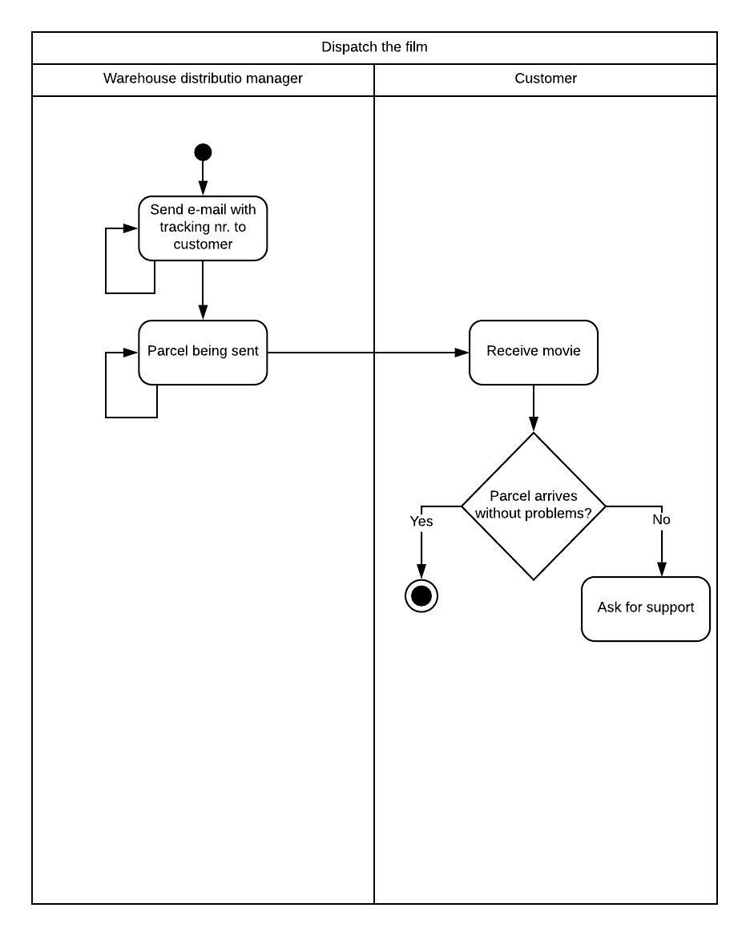

**Class Diagrams**

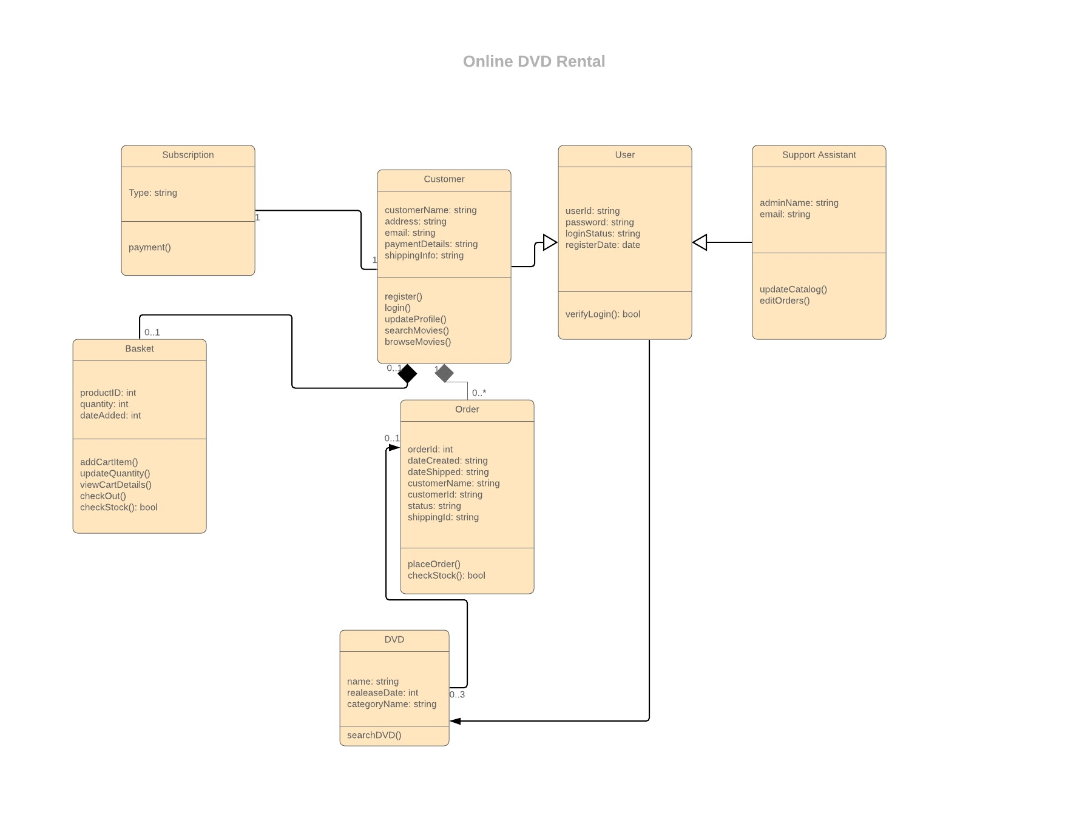

**Sequence Diagram:**

